The Chief Executive
Dunedin City Council
PO Box 5045
Dunedin
New Zealand

21 April 2023

West Harbour Community Board (WHCB) Submission to the Dunedin City Council Annual Plan 2023/24

INTRODUCTION
West Harbour is a coastal Dunedin community where most residents live within easy walking distance of the Otago Harbour and the ocean. Proximity to healthy land and water is one of the most precious resources for our community, and the intrinsic, aesthetic, spiritual and mental health benefits value that comes with living adjacent to nature.
The West Harbour community value access to kai moana, the recreational and commercial opportunities afforded due to living adjacent to Otago Harbour, and the conservation and recreation value of Orokonui Ecosanctuary, among others.
Our community feel deep affinity with the Otago Harbour and the marine area that surrounds us, however our community are conscious of and concerned that there is considerable and increasing pressures placed on the outlying coastal communities such as the precious environments of Osbourne, Pūrākaunui, Long Beach/Warauwerawera, and Aramoana. In addition, West Harbour is the gateway to Dunedin city, with almost one hundred cruise ship visits bringing close to 150,000 passengers and 73,000 crew members into the area over the 2022/23 cruise ship season.
Along West Harbour we are proud to offer manaaki to our visitors, and we ask that the Dunedin City Council (DCC) help us to maintain our piece of paradise as the wonderful place it is to grow up, live, work, play, and visit, whilst maintaining West Harbour as the priceless piece of Dunedin’s historic and wild environment that it is.
As the gateway to Dunedin for thousands of visitors every year, more concerted action from the DCC is required to improve public amenities, roading, and pest management across West Harbour.
The West Harbour Community Board (WHCB) are broadly supportive of the DCC’s proposed 2023/24 Annual Plan to ensure Dunedin is a supportive, caring community with a great quality of life, a healthy and sustainable city with healthy and treasured natural environments, and an active city with quality and accessible recreational spaces and opportunities.
The WHCB would like to elaborate specifically on urgent health and safety concerns (1-4), the two dam closures proposed in the DCC long-term plan (5), hygiene and health concerns around inadequate provision of public toilets (6), and Environmental concerns (7-9).

SUBMISSION POINTS
- Infrastructure Shared Pathway Terminus – Port Chalmers Main Street Upgrade
The West Harbour community are excited to see the shared pathway nearing completion. This will be a considerable and positive addition to the West Harbour community. Unfortunately, the shared pathway terminus at Port Chalmers presents a considerable Health and Safety issue. The pathway finishes immediately adjacent to the unbarricaded railway crossing on Wickliffe Terrace. Port Chalmers urgently requires bike stands to cater for the increase in cycle traffic that will inevitably follow the completion of the shared pathway. There will be frequent gatherings of groups often including young children at the start of the shared pathway, as is currently the case at St Leonard’s. Many commuters travel by car to St Leonard’s and then use the bike path accommodation needs to be made for these activities along the main street of Port Chalmers (George Street).
WHCB request a safer solution for the shared pathway terminus at Port Chalmers and the installation of cycle parking stands as part of the Port Chalmers Main Street Upgrade scheduled for 2023/24.
- Aramoana Domain Parking
WHCB appreciate the DCC support in installing the new playground at the Aramoana Domain. The playground is extremely well-used and a wonderful addition to the community. There is currently safe parking for a maximum of two vehicles outside the gate at Aramoana Domain, meaning visitors often park along the road partially blocking the road and obscuring the line of site for drivers. With increased use of the playground by local tamariki/children and visitors this presents a Health and Safety issue which could easily become a tragedy.
WHCB request that a parking zone for 10-12 cars be added to the Aramoana Domain along the newly revegetated zone to the left of the entrance gate inside the domain ground, cordoned off with bollards/chain, or similar, that could be removed for large, organised events.
- Back Beach Parking and Otago Harbour User Working Group
Increasing recreational and commercial use of the Otago Harbour is placing strain on the natural environment and brings with it many Health and Safety considerations. With the return of cruise ships post COVID19 and the completion of the Port Chalmers to Dunedin and Dunedin to Portobello Shared pathways, both recreational and commercial use across Otago Harbour and adjacent communities will increase. Concern has been raised around the Back Beach, Port Chalmers Parking area and the congestion of this area through increased commercial use. This parking area was being used as a staging, waiting area by cruise ship shuttle buses (2022/23 season) causing a significant Health and Safety issue with several near misses and in one case a trailer being dragged along by a bus.
WHCB request DCC support in calling on the ORC to form a ‘Otago Harbour User Working Group’ that includes recreational, commercial and governance bodies.
WHCB request community consultation to find a workable solution for this valued parking area.
- Road and footpath Maintenance
Many of West Harbour’s roads and footpaths are in need of repair, e.g., Mary street (Port Chalmers), Wanaka street (Ravensbourne, See photos), McAndrew Road (Carey’s Bay), Aramoana settlement, Osbourne Main road.
The main Aramoana road from Port Chalmers to Aramoana has overhanging and slip prone trees, rocks, and clay along the length of the road. Every large rain event brings rubble and rocks onto the road. Larger storm events bring down trees blocking the road entirely. King tides and storm events regularly erode the gravel behind the seawall and cover the harbour lane in large areas of loose stones. This road has blind corners, no hard shoulder, and few places where it is safe to pull off the road. Residents in the Aramoana community commute daily to school and work. This is a Health and Safety issue and a fatality waiting to happen, either through falling debris hitting someone or someone avoiding debris and ending in the harbour. The hill edge of the Aramoana main road desperately needs work.
WHCB request a review of the road and footpath maintenance schedule for West Harbour.
WHCB request the main Aramoana Road be reviewed and appropriately maintained for Safety.
- West Harbour Dam closures
We are concerned about the planned closure of the “two raw dams and water treatment plant at Port Chalmers” (page 12, DCC 10 year plan 2021-31).
Dunedin has recently been under voluntary water restrictions. Climate change and local population growth will only increase the pressure on supply and demand. Closing two of Dunedin City’s seven dams could be a decision Dunedin would soon regret.
The Cedar Creek and Rossville Dams are important to the resilience of West Harbour communities in times of natural disaster or for local fire fighting. If West Harbour is cut off from the rest of the city, the main pipeline is damaged, or the Mt Grand water supply is contaminated (as happened in 2019), these dams provide much needed water supply. There are also concerns about the loss of amenities value of the superb parklands around these dams, which are popular for recreational use.
WHCB request consultation and review of this decision.
- Port Chalmers Pool
West Harbour is community with strong ties to the water. Recreational access to the Harbour and Ocean is a strong motivation for many residents choosing to live in West Harbour. Collectively we love the water. We also recognise that the water can be a dangerous place, 2022 saw a 14-year record high in NZ drownings (94 people lost their lives in NZ waters). 2023 drownings are already ahead of 2022 numbers (NZ Water Safety, https://www.watersafetynz.org/drowning-insights). The Port Chalmers pool is a vital part of the West Harbour community commitment to enjoying our marine environment safely. Every year Port Otago ensures our West Harbour tamariki have access to free swimming lessons at the Port Chalmers pool. Residents used the Port Chalmers pool 11 362 times during the 2019/2020 season (DCC Long term plan, p122). The Port Chalmers pool is a well-used, and essential amenity.
WHCB request the Port Chalmers pool season and hours be extended.
- Public toilets
Enjoyment of the outdoors for recreation and community events around West Harbour is dependent on a clean healthy environment that does not create a Health Hazard. This is particularly true for areas of West Harbour that experience an influx of visitors and where no, or few, supplementary public facilities exist. Public toilets in and around Dunedin City were the most commented item (1,023 submissions to the 2021-31 Long term Plan). We understand that other community boards and wilderness areas also require more public toilets. However, the current rate of increase in supplying this basic human need is insufficient. This has led to public fouling (human waste) in some of our most precious Wild Dunedin environments. With the completion of the shared path from Dunedin to Port Chalmers the number of visitors, cyclists, dog walkers and family groups enjoying West Harbour will increase, we need facilities in place, in advance to avoid people being caught short and resorting to a nearby tussock or bush. A tussock or bush that the next group of children are playing, running, and falling on. The Long-term plan has a very conservative plan for increasing the number of public toilets in Dunedin we would request this be substantially increased and installation moved forward.
- WHCB appreciate the anticipated installation of public toilets on the Harbour Cycleway (shared path) at St Leonards (2022/23). We look forward to its completion before the 2023/24 cruise ship season begins in October.
- WHCB request that the scheduled public toilet installation at Pūrākaunui be moved forward from 2028/29 to 2023/24.
- WHCB request public toilets be installed at Sawyers Bay (currently without public toilets of any form). Sawyers Bay is a popular residential area for young families and the connection to the shared path will inevitably increase the need for more accessible public toilets.
- WHCB request permanent public toilets be installed at the Aramoana mole. The completion of the shared path will increase the number of cyclists along West Harbour and the ease of access to Aramoana. The DCC need to proactively cater to the increased need for public amenities in these high-pressure, high-risk Wild Dunedin Environment. Aramoana is an extremely popular spot for surfers, dog-walkers, families, walkers, lack of public toilets adjacent to the beaches presents a significant Health and Safety problem.
- Following the post-covid return of cruise ships this season (2022/23) George Street, Port Chalmers public toilets were unable to cope with the demand. At times going three days without cleaning, frequently out of toilet paper and unclean. This is a poor welcome to Dunedin for the almost 150 000 cruise ship passengers that visited this season. WHCB request public toilets be installed at Centennial Park / shared pathway terminus in time for the 2023/24 Cruise ship season.

- Dog poo bins
Dog poo is a significant problem in multiple sites across West Harbour. Specific complaints and areas of concern are, Aramoana, Port Chalmers, Back Beach, and the Shared Pathway. If nothing is done this problem will increase with the completion of the new shared pathway. Given the prominence of Port Chalmers as the disembarkation location of the cruise ship passengers to Dunedin presenting a clean environment is essential to Dunedin’s brand image. We believe that social pressure, and subliminal signalling through visible, attractive signage, bag dispensers and designated bins will have a considerable effect.
WHCB request that the DCC trial the use of marine grade dog-poo-bag dispensers and dog-poo bag bins (e.g., like those installed by Nelson; https://bit.ly/3mO0PjZ) along the Shared Path and Back Beach.
- Control of Noxious weeds and Pest Management
West Harbour is home to many native and endangered birds, reptiles, invertebrates, and plants, as well as being frequently visited by migratory marine mammals and sea/coastal birds.
West Harbour borders Orokonui Ecosanctuary in the West, and Otago Harbour in the East. The area is within easy pest swimming/dispersal distance of the Otago Peninsula and Otago Harbour islands. The geographical proximity to some of Aotearoa New Zealand’s most precious biodiversity means that West Harbour is a vital link in Otago’s efforts to protect native and endemic flora and fauna.
Site-Led Programmes for “West Harbour – Mt Cargill”, and “Quarantine and Goat Islands / Kamau Taurua” areas are in place and include Banana Passionfruit, Darwin’s Barberry, Sycamore, Gunnera, and Tradescantia) and pest animal species such as feral cats, feral rabbits, feral goats, feral pigs, mustilids, rats, hedgehogs, and possums (Page 59, The Otago Regional Council Pest Management Plan).
WHCB request DCC support in obtaining our long term goals for a pest free West Harbour through more active monitoring, management, and eradication of noxious weeds and pest across West Harbour. This is particularly important in DCC reserves and along the shared pathway, and road network.
- Protecting Aramoana Ecological Area from erosion
West Harbour is home to the magnificent Aramoana Ecological Area, an extensive protected wetland ecosystem with a strong ecological zonation. The existing board walk provides easy access for the public without risk to the integrity of the salt-meadow and the site is frequently visited by school groups from across Dunedin. This land is a significant part of the Dunedin City Wild Environment and Heritage. The issues are complicated by various local, regional, and national organisations overseeing overlapping and adjoining areas.
There is grave concern from the local community that long term lack of maintenance for the existing Long Mac Groyne structure is putting this nationally identified Ecological Area, and the historic pilot houses along the spit, at serious risk of inundation and erosion with each king tide and storm surge.
The Ecological Area has been the focus of many scientific research projects and is highly prized by the NZ ecological and the local community for both its aesthetic and conservation values. The area is host to special saltmarsh plants and shrubs, and is a vital feeding spot for a large number of birds, including godwits, banded dotterels, pied stilts, plovers, herons, kingfishers and oyster catchers.
WHCB understand that this is largely an ORC/ DOC concern. WHCB request DCC support in commissioning a review and solution that will preserve these heritage buildings, the Aramoana Ecological Area (wetland), renovate/restore the Aramoana spit historical wharf, and support the formation of the Otago Harbour User Working Group.

Thank you for the opportunity to make this submission to the 2023/24 annual plan.
We would appreciate the opportunity to speak to this submission.

Regards,

Dr Barbara Anderson
Ph: 022 102 0822
Email: drBarbaraJAnderson1@gmail.com

Wayne Sefton
Jarrod Hodgson
Kristina Goldsmith (Deputy Chair WHCB)
Angela McErlane (Chair)

Figure 1 Wanaka Street (Ravensbourne)
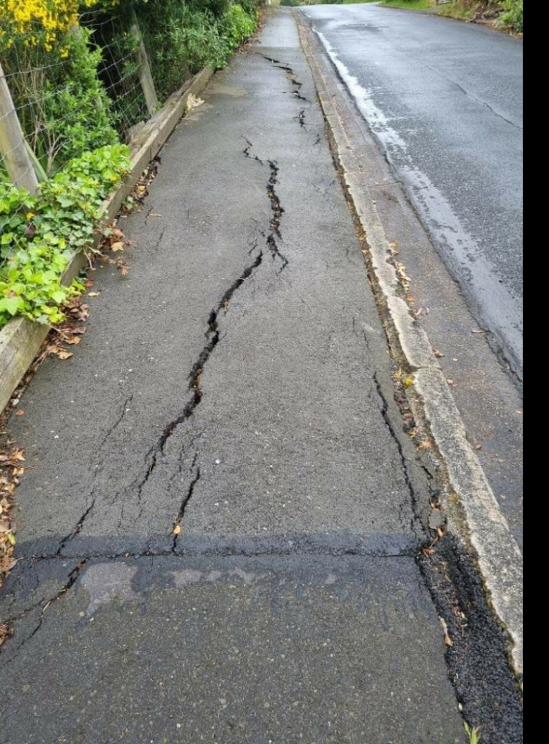

Figure 2. Wanaka Street (Ravensbourne)